Работен лист по английски език
Име ………………………………………………………………………………
The English Alphabet
Произнесете названията на буквите и прочетете думите. Напишете всяка буква по пет пъти и всяка дума – по три пъти. Успех!

Aa ……………………………………………………………………………………………………………
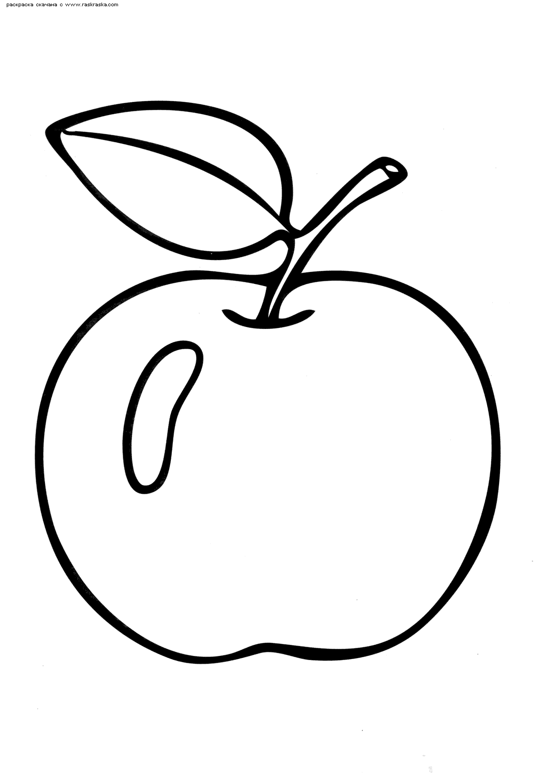apple................................................................................................................................
Bb……………………………………………………………………………………………………………
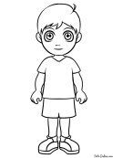boy…………………………………………………………………………………………………
Cc………………………………………………………………………………………………………………
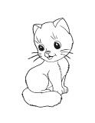cat…………………………………………………………………………………………………
Dd……………………………………………………………………………………………………………
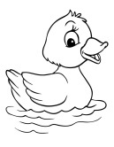duck……………………………………………………………………………………………

Ee………………………………………………………………………………………………………………
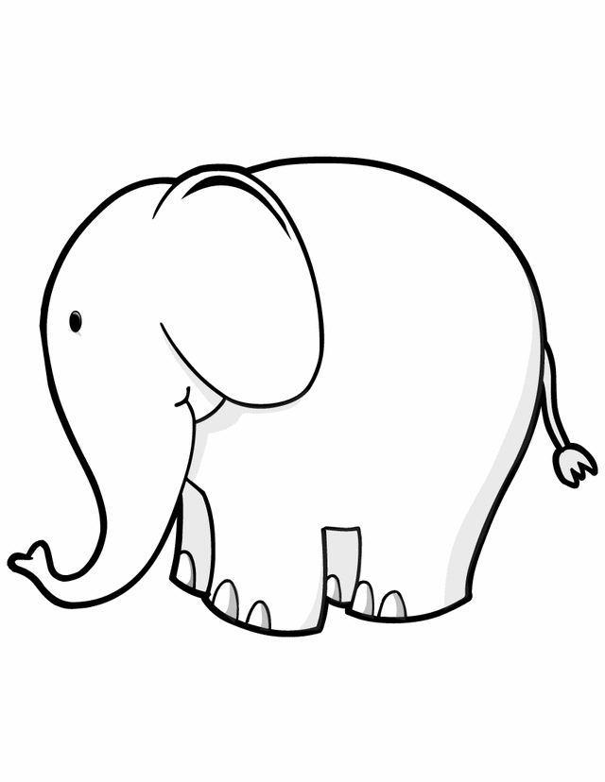elephant…………………………………………………………………………………
Ff………………………………………………………………………………………………………………
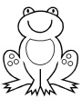frog…………………………………………………………………………………………………
Gg………………………………………………………………………………………………………………
girl…………………………………………………………………………………………………
Hh……………………………………………………………………………………………………………
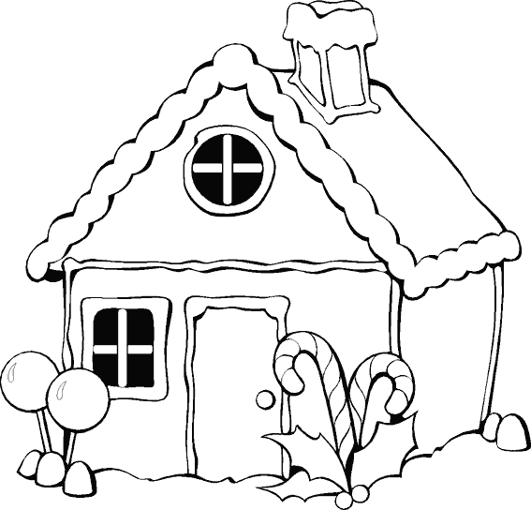house…………………………………………………………………………………………
Ii………………………………………………………………………………………………………………….
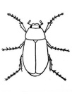insect……………………………………………………………………………………………
Jj…………………………………………………………………………………………………………………
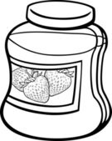jar…………………………………………………………………………………………………….

Kk……………………………………………………………………………………………………………
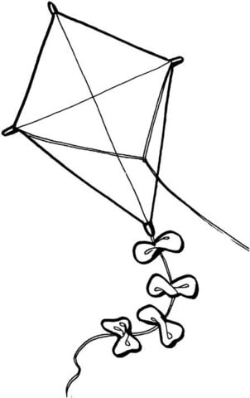kite…………………………………………………………………………………………………
Ll………………………………………………………………………………………………………………..
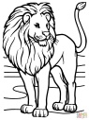lion…………………………………………………………………………………………………
Mm…………………………………………………………………………………………………………
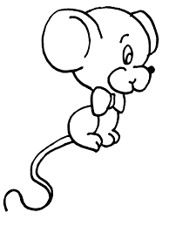mouse…………………………………………………………………………………………
Nn……………………………………………………………………………………………………………
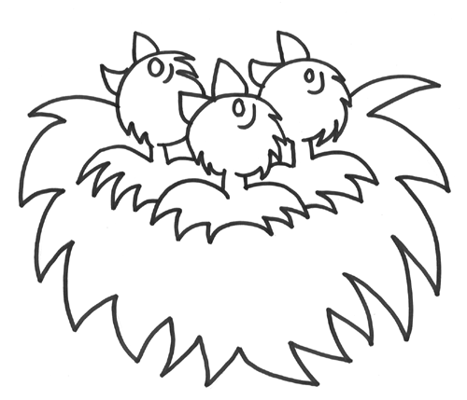nest………………………………………………………………………………………………
Oo……………………………………………………………………………………………………………
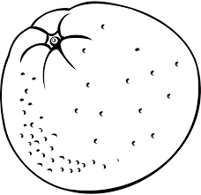orange………………………………………………………………………………………
Pp………………………………………………………………………………………………………………
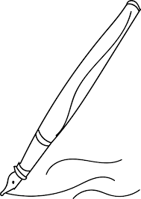pen……………………………………………………………………………………………………

Qq……………………………………………………………………………………………………………
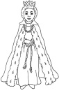queen…………………………………………………………………………………………
Rr………………………………………………………………………………………………………………
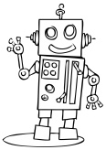robot……………………………………………………………………………………………
Ss……………………………………………………………………………………………………………
smile……………………………………………………………………………………………
Tt………………………………………………………………………………………………………………
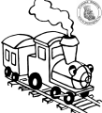 train……………………………………………………………………………………………
Uu……………………………………………………………………………………………………………
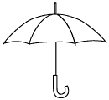 umbrella…………………………………………………………………………......
Vv………………………………………………………………………………………………………………
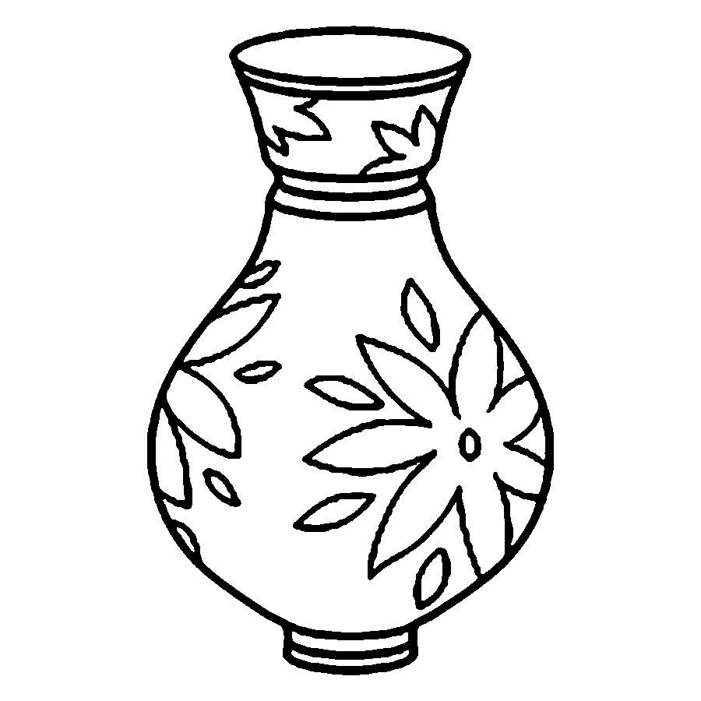vase………………………………………………………………………………………………

Ww…………………………………………………………………………………………………………
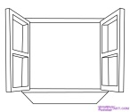window…………………………………………………………………………………
Xx………………………………………………………………………………………………………………
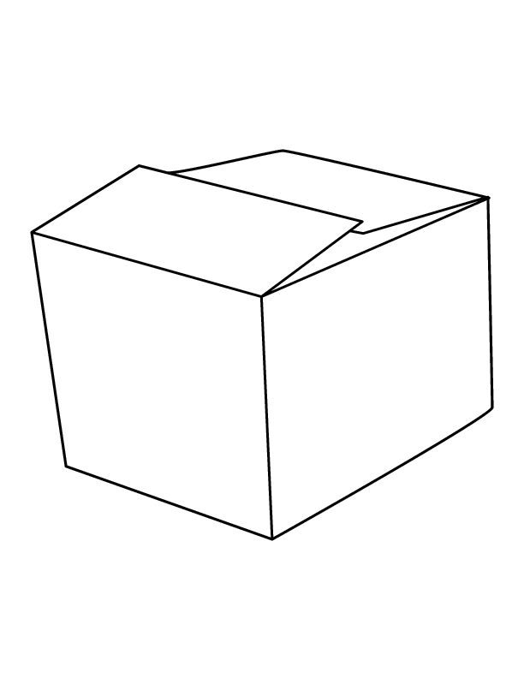box………………………………………………………………………………………………

Yy………………………………………………………………………………………………………………..
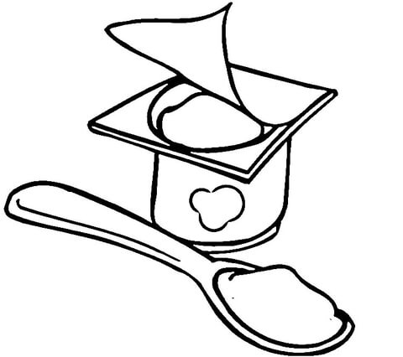yogurt………………………………………………………………………………………
Zz…………………………………………………………………………………………………………….
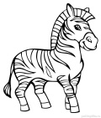zebra……………………………………………………………………………………………

 

